Document Authentication and Verification
Namita Sarode¹, Reshma Shendge², Komal Kankariya³, Vishal Khatal⁴
Abstract— The leading problem in passport, driving license, identity card authentication is to authenticate the document for its owner. The critical factor of this authentication procedure is to establish a correspondence between document's photo and its owner. A document contains holder details in supplement to the holder’s signature. We propose an authentication scheme by extracting some details of the holder including number, name, and other relevant details converting them into a watermark and digesting them in a form by applying some techniques that can be hidden in the photo. The computers have revolutionized the document authentication process by using the computer in fixing the photo on the document during the issuing of document and also verifying the document by scanning it. During the issue of any document, a watermark can be created based on the details of the holder full name and unique number and it can be hidden in the photo on the document using watermarking technique. With the help of this technique, during the document verification process, computer can be used in scanning the photo to check whether the photo has been replaced by comparing the invisible watermark hidden in the photo with the holder’s details including the full name and other relevant details. Because this technique has used only one pixel for hiding the watermark, it satisfied the robustness against image compression.
¹K.Wagh Institute Of Engineering Education And Research,
Department of Computer Engineering, Nashik.
²K.K.Wagh Institute Of Engineering Education And Research,
Department of Computer Engineering, Nashik.
³ K.K.Wagh Institute Of Engineering Education And Research,
Department of Computer Engineering ,Nashik.
⁴K.K.Wagh Institute Of Engineering Education And Research,
Department of Computer Engineering ,Nashik.
namita.sarode@gmail.com, reshmas2207@gmail.com, komalkankariya555@gmail.com , vishkhatal@gmail.com

Index Terms— Authentication, Robustness, Steganography, Watermarking.

INTRODUCTION
  - Steganography
Steganography is the art and science of encoding hidden messages in such a way that no one, apart from the sender and intended recipient, suspects the existence of the message. It is a form of security through obscurity. The word steganography is of Greek origin and means "concealed writing". It combines the Greek words steganos (στεγανός), meaning "covered or protected", and graphei (γραφή) meaning "writing".
The advantage of steganography over cryptography alone is that the intended secret message does not attract attention to itself as an object of scrutiny. Plainly visible encrypted messages—no matter how unbreakable—will arouse interest, and may in themselves be incriminating in countries where encryption is illegal. Thus, whereas cryptography is the practice of protecting the contents of a message alone, steganography is concerned with concealing the fact that a secret message is being sent, as well as concealing the contents of the message.
Steganography includes the concealment of information within computer files. In digital steganography, electronic communications may include stganographic coding inside of a transport layer, such as a document file, image file, program or protocol. Media files are ideal for steganographic transmission because of their large size. For example, a sender might start with an innocuous image file and adjust the color of every 100th pixel to correspond to a letter in the alphabet, a change so subtle that someone not specifically looking for it is unlikely to notice it.

  - Digital Watermarking
A digital watermark is a kind of marker covertly embedded in a noise-tolerant signal such as audio or image data. It is typically used to identify ownership of the copyright of such signal. "Watermarking" is the process of hiding digital information in a carrier signal; the hidden information should, but does not need to contain a relation to the carrier signal. Digital watermarks may be used to verify the authenticity or integrity of the carrier signal or to show the identity of its owners. It is prominently used for tracing copyright infringements and for banknote authentication. Like traditional watermarks, digital watermarks are only perceptible under certain conditions, i.e. after using some algorithm, and imperceptible anytime else. If a digital watermark distorts the carrier signal in a way that it becomes perceivable, it is of no use. Traditional Watermarks may be applied to visible media (like images or video), whereas in digital watermarking, the signal may be audio, pictures, video, texts or 3D models. A signal may carry several different watermarks at the same time. Both steganography and digital watermarking employ steganographic techniques to embed data covertly in noisy signals. But whereas steganography aims for imperceptibility to human senses, digital watermarking tries to control the robustness as top priority.
Since a digital copy of data is the same as the original, digital watermarking is a passive protection tool.
There are a number of requirements for watermarking Techniques:
Robustness: The embedded information is said to be robust if its presence can be reliably detected after the image has been modified, but not destroyed beyond recognition.
Invisibility: This concept is based on the properties of the human visual system or the human audio system. The embedded information is imperceptible if an average human subject is unable to distinguish between carries that contain the hidden information and those that do not.
Undetectability: The concept of undetectability is inherently tied to the statistical model of the image source. If an attacker has a more detailed model of the source, he may be able to detect the presence of a hidden image, but this does not imply the ability to read the hidden message.
Security: The embedding algorithm is said to be secure, if the embedded information can not remove beyond reliable detection by targeted attacks based on a full knowledge of the embedding algorithm and the detector (except the secret key).Nowadays, computer involved in all life details. One of these issues is producing the document by using the computer application. To fill full this objective there are several requirements such as using a computerize photo for the document holder with special colors (grey and white). Also most of the document offices are connected through a network to exchange their information about the correctness of document information and the authentication of the document holder. It is possible to transfer the image between different offices to get information confirmation.
Here, the main problem is how to confirm and
authenticate the document holder's photo with the information about the holder. There is no other way to tell if the photo been replaced with a new one (for the current holder) because there is no physical connection between the photo and the holder’s details.

Existing system
The existing system is based on authentication of passport only. The aim of the existing algorithm is to provide a firm association between the holder’s photo and the holder’s details. The existing algorithm used the watermarking technique to create an association between the photo and holder’s details by embedding hidden information in the photograph. The existing algorithm uses the holder’s first name, second name, third name, family name and document number and converts into an invisible watermark. This invisible watermark is embedded inside the photo such that it satisfies all the requirements of the watermarking technique. This process is carried out during the issue of the document at the office. The existing algorithm consists of three algorithms. The first algorithm deals with acquiring the required parameters for creating the watermarking. The second algorithm converts the holder’s details into a watermark that can be embedded into the digital image. The third algorithm hides the watermark obtained inside the photo such that it meets the requirements of the watermarking.
2.1 Drawbacks
1. Due to rapid advancement in technology, new tools were invented to compare original image and Steganography image to detect the presence of hidden information in a Steganography image.
2. Suppose a Steganography image is created by existing method values of row, Rcolumn can be obtained by
Comparing original image with Steganography image
3. An attacker having the full knowledge of the algorithm,
can be able to crack the key value by running a program
on super computers by trial and error method.

Proposed system
The proposed system is designed for various documents like employee’s identity,driving license,passport,etc.This system can be used for authentication and verification of any document which contains photo in it.The aim of the proposed method is to develop a firm connection between the photo and the holder's details. In this case it is possible to use this method for confirmation of holder’s information.
The summery of this method is by converting the holder's name (1st, 2nd, 3rd and family name) in addition to the document number into one form called an invisible watermark. This watermark will be disguised and distributed inside the photo. This process will be done during the issue of the document for the first time. All the watermark requirements will be considered. The proposed method consists of several algorithms. Each algorithm is responsible for one type of process. All the required validations processes will be taken in consideration by the proposed method. The following algorithms are used in the proposed method.In consideration we have considered passport document :

3.1. Algorithm 1: Acquire Parameters
1. Get holder’s first name, second name, third name and
surname.
2. Get holder’s document Number.
3. Validate the holder’s details.
4. Assign a number to each letter of the name according to
the table 1.
5. Store each name’s numbers for future reference

3.2. Algorithm 2: Watermark
1. Consider the key value. E.g. K = "1, 2, 3, 4".
2. Create a new key value for first name by summing the
consecutive key values in a round robin fashion say K1.
Where K1(1)=K(1)+K(2)
K1(2)=K(2)+K(3)
K1(3)=K(3)+K(4)
K1(4)=K(4)+K(1)
Compute the summation of the first name by adding the
code value of each character multiplied by the new key’s
character in succession.
E.g. codeval(1)*K1(1) + codeval(2)*K1(2) +
codeval(3)*K1(3)+……
3. Consider the result as "row”.

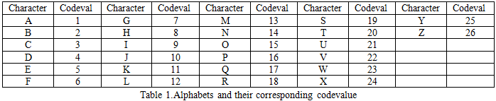

4. Create a new key value for second name by summing
the alternate key values in round robin fashion say K2.
Where K2(1)=K(1)+K(3)
K2(2)=K(2)+K(4)
K2(3)=K(3)+K(1)
K2(4)=K(4)+K(2)
Compute the summation of the second name by adding
the code value of each character multiplied by the
new key’s character in succession.
E.g. codeval(1)*K2(1) + codeval(2)*K2(2) +
codeval(3)*K2(3)+…….
5. Consider the result as "column ".
6. Compute the summation of the third name and family
name by adding the code value of each character
multiplied by the actual key's character in succession.
E.g. codeval(1)*K(1) + codeval(2)*K(2) +
codeval(3)*K(3)+……
7. Compute the summation of document number by adding
the code value of each character.
E.g. codeval(1) +codeval(2)+ codeval(3)+……
8. Compute the sum of third name, family name and the
Document number and store the result in "sum".

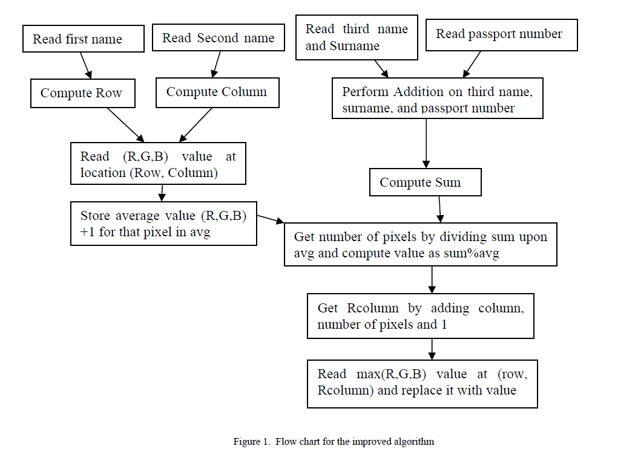

3.3. Algorithm 3: Hide Watermark
1. Get the pixel value at (row, column) location from the
original Image.
2. Find the average value of RGB [6] color for that pixel,
add 1 to it and assign it to "avg ".
3. Divide "sum" on "avg" to get number of pixels.
4. Compute the modulo division of "sum" over "avg" and
store result in "value ".
5. Calculate Rcolumn which is equal to "column" +
"number of pixel" + 1.
6. Get the pixel value at location (row, Rcolumn).
7. Get the largest value of (R,G,B) for the pixel at that
location and replace it with "value".
8. Restore the pixel (R,G,B) values at the same location.

3.4. Algorithm 4: Authenticate
1. Select the image for which watermarking is to be applied.
2. Read the document number for which the authentication is
to be performed.
3. Perform row, column and sum computations as shown
in algorithm 2 by retrieving the details from the database
based on the document number.
4. Compare the row, column and sum values obtained with
the values stored in the database
5. If the step 4 is successful, perform number of pixels and
value computations as shown in algorithm 3 and compare
the results with the values stored n the database.
6. If the step 5 is successful, allow the holder to travel
otherwise take legal proceedings on the passport holder.

Analysis

Algorithm one will accept the passport holder full Name and his passport number for the creation of watermark, which is validated to make sure that all the given information is correct.
Each letter in Full name is assigned a codeval chosen from table 1.this table contains the alphabets and their equivalent numbers.The following equation can be used to compute the code value for each character.
Codeval(character)=ASCII value(character)-64.
By the end of each algorithm one each name(first,second,third and surname)has a sequence of numbers assigned to each name depending on the length of name.
Algorithm two starts by selecting a kay K(e.g 1,2,3,4) and then calculating the key value for each name according to algorithm as follows:
For First name, a separate key value is calculated (say K1)
As
K1(1)=K(0)+K(1)
K1(2)=K(1)+K(2)
K1(3)=K(2)+K(3)
…………………………………
For Second name, a separate key value is calculated (say K2)
As
K2(1)=K(0)+K(2)
K2(2)=K(1)+K(3)
…………………………………

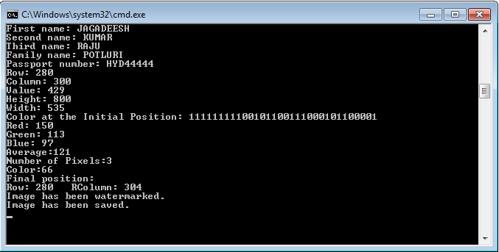

Fig.2:Implementation Of Passport Generation Module

For Third name and surname, actual key value is taken into consideration then the value for each name is calculated by multiplying code value for each character by corresponding key digits arranged in sequence and summing up the values.
For the passport number each number each digit is converted to a code value and is summed in sequence.
e.g. codeval(1)*K1(1) + codeval(2)*K1(2) +
codeval(3)*K1(3)+……for first name
codeval(1)*K2(1) + codeval(2)*K2(2) +
codeval(3)*K2(3)+……for second name
codeval(1)*K(1) + codeval(2)*K(2) +
codeval(3)*K(3)+……for third name,surname.
Pno(1)+pno(2)+……..for passport number
The following equations could be used to calculate value for each name
J=m
I=n
Σcodeval(i)*K(j)
I=1
J=1
Where, n=length of name and m= length of key. And K refers to K1 for first name, K2 for second name and K for third name and surname.
Suppose first name is JAGADEESH
Second name is KUMAR
Third name is RAJU
surname is POTLURI
Passport number is HYD44444
Actual Key value is 1234
Value of JAGADEESH is row=280
Value of KUMAR is column=300
Value of RAJU is 134
Value of POTLURI is 238

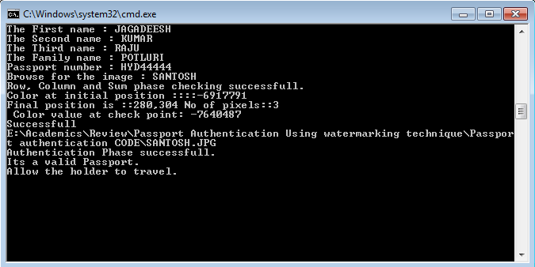

Fig.3 Implementation of passport authentication module

Value of passport number is 57
Value of sum = 429
The algorithm three is for the hiding the watermark
obtained during algorithm two. According to this algorithm we read the value of the pixel at location (row, column) from the actual passport photo. Then we find the average value of (R,G,B) color for the pixel, add 1 to it and we call it "avg". After we divide the "sum" on "avg" to obtain the number of pixels. We use modulo of "sum" over "avg" to get "value". Then we calculate the new column for the pixel to be hidden i.e. Rcolumn as column number of pixels + 1. Then value of max(R,G,B) for pixel(row, column) is replaced with value.
Improved algorithm has an advantage over existing algorithm in terms of security. The improved algorithm uses different keys for first name, second name and third name, family name which does not allow intruder to crack key given the full knowledge of algorithm. So it satisfies the security requirement of watermarking. Also improved algorithm overcomes the divide by zero exception that may occur in the existing algorithm by adding positive quantity(1) to the avg. So the improved algorithm overcomes the drawbacks of the existing algorithm.

conclusion
This authentication scheme embeds the invisible watermark into the photo to authenticate the document owner. This modified scheme meets all the requirements for the watermark technique. The invisible watermark has satisfied the robustness, Invisibility, Undetectability and Security requirements. Because this technique has used only one pixel for hiding the watermark, it satisfied the robustness against image compression. The detection of presence of hidden information is a daunting task as it is time consuming to predict the key value. So it satisfies the security requirement of watermarking. It also satisfies invisibility requirement because change in one pixel is not visible to the human eye.

The watermark also satisfies the Undetectability requirement since the pixel size is very small compared to the size of an image and is not easily noticeable. This method is effective and meets all the requirements of watermarking. This scheme is applicable for only one State. So to make the authentication scheme globally feasible, every state should share keys using asymmetric key cryptography. Every state should use the public key to hide the watermark during the issue of passport and private key should be used during the verification process at the checkpoint to check the authenticity of the passport.

REFERENCES

[1] AlaaH.Al-Hamami and SaadA.Al-Ani, Faculty of Information Technology, Amman Al-Ahliyya University, Amman, Jordan “A New Approach for Authentication Technique”Journal of ComputerScience 1 (1): 103-106, 2005 ISSN 1549-3636 © Science Publications, 2005
[2] ManjitThapa, Dr.Sandeep Kumar Sood, A.P Meenakshi Sharma “Digital Image Watermarking Technique Based on Different Attacks”. (IJACSA) International Journal of Advanced Computer Science and Applications, Vol. 2, No. 4, 2011
[3] Er. Deepak Aggarwal, Er. Kanwalvir Singh Dhindsa
“Effect of Embedding Watermark on Compression of the DigitalImages” JOURNAL OF COMPUTING,VOLUME 2, ISSUE 2, FEBRUARY 2010, ISSN 2151-9617
[4] Christian S. Collberg, Member, IEEE Computer Society, and Clark Thomborson, Senior Member, IEEE “Watermarking, Tamper-Proofing, and Obfuscation Tools for Software Protection” IEEE TRANSACTIONS ON SOFTWARE ENGINEERING, VOL. 28, NO. 8, AUGUST 2002
[5] Stefan, K. and F.A.P. Petitcolas (Eds.), 2000. Information Hiding techniques for steganography and digital watermarking. ISBN 1-58053-035-4 © Artech House, Inc.

 

